**Level 5: AI Game Programming**

**Week 4**

**Lab 4**

Lab sheet revised by Wen Tang on 01/10/2025

RECORD ALL THAT YOU DO IN YOUR LAB LOGBOOK (HARDCOPY ‘OR’ WORD FILE).

*It is strongly recommended that you implement your code in Google Colab using Python. You need to use Python and Colab in your assignment.*

**Part 1 Recap from Week 3 lab**

**Training a single neuron (perceptron) to learn a simple task using the error**

We’ve learned the method to train a single neuron to do a decision task by using the error at the output of the neuron.

You already implemented the simple training algorithm in the lab last week. The puzzle occurred as most of your implementation won't give you the correct results (. Since then, your brain has had some time to digest the idea. Today we will revisit the code again with some additional information. Can you figure out what goes wrong?

**RECAp**

From the lecture last week, as an example, a neuron called ‘perceptron’ (single neuron with two inputs and one output) is shown below:

In this case, the output Y is defined by **Step function**

Where θ is the threshold (equal to 0.2 in this example).

Example: two input signals and x1 = 0.2, x2 = 0.1, w1 = 1.0, w2 = 0.2, θ = 0.2

X = x1*w1 +x2*w2 = 0.22

X >= θ, therefore Y (output) = 1

**Training**

In this lab, again, we will train our single neuron to learn to handle a game NPC’s decision-making process – that is, whether the NPC will attack or flee, depending on the its power and enemy’s power.

|  |  |  |
| --- | --- | --- |
| Input | | Output |
| NPC's power () | Enemy's power () | NPC’s decision/action (*Y*) |
| Weak (0) | Weak (0) | Flee (0) |
| Weak (0) | Strong (1) | Flee (0) |
| Strong (1) | Weak (0) | Flee (0) NB: the NPC has high moral standards and does not want to attack a weaker enemy. |
| Strong (1) | Strong (1) | Attack (1) |

*To train or to make your neuron learn to make decision is to* ***adjust the weights*** *to correct values so that your neuron can produce correct output or decision when given a set of inputs. In this example, that means finding the fixed correct values for and which produce the correct outputs for 'all' combinations of inputs.*

Note that our neuron model cannot accept ‘weak’, ‘strong’, ‘flee’ or ‘attack’. Everything must be '**encoded'** or represented in a numerical form. Therefore, as shown in the table, weak = 0, strong = 1, flee = 0 and attack = 1.

**TASKS**

**Task 1: training one single neuron using the method explained in the lecture**

We will have a look at the training method described in the lecture. This is the ***'Mysterious gift from heaven'*** mentioned in the last lab.

We use the error (the difference between the correct output Y and the output produced by your neuron when using the current weights) to guide the changes of the weight's values to move closer to the correct values.

Or, in a more formal presentation:

**Example pseudocode from last week**

Note that an ***epoch*** means training your neuron with all the training data (4 cases in this example) for one cycle of training. This is a parameter you have to set. You increase the number of epoch if the training does not convert to produce correct results.

For simplicity, let the step function threshold θ = 0.2 and set the learning rate = 0.1.

In practice, you would initialise the weights by using random numbers. But it's a nightmare to debug. Therefore, you can manually set the initial values first. (In this case, w1 = 0.3, w2 = -0.1.) Once your code works properly, then you can randomly initialise the weight values.

If your code works correctly, the final correct weights should be .

**Hint:** If your program does not produce the correct weights, for each step, check the results against the following table and adjust your code accordingly. This is a good way to practice implementing and debugging your code. When you find the error, think about what is the best way to solve this problem.

|  |  |  |  |  |  |  |  |  |  |  |
| --- | --- | --- | --- | --- | --- | --- | --- | --- | --- | --- |
| Epoch | Case number | **Input** | | **Correct output** | Current weights | | Current output | Error | Updated new weights | |
| **x1** | **x2** | **Yd** | w1 | w2 | Y | e = Yd-Y | w1 | w2 |
| 1 | 1 | **0** | **0** | **0** | 0.3 | -0.1 | 0 | 0 | 0.3 | -0.1 |
| 2 | **0** | **1** | **0** | 0.3 | -0.1 | 0 | 0 | 0.3 | -0.1 |
| 3 | **1** | **0** | **0** | 0.3 | -0.1 | 1 | -1 | 0.19999 | -0.1 |
| 4 | **1** | **1** | **1** | 0.1999 | 0.1 | 0 | 1 | 0.3 | 0.0 |
| 2 | 1 | **0** | **0** | **0** | 0.3 | 0.0 | 0 | 0 | 0.3 | 0.0 |
| 2 | **0** | **1** | **0** | 0.3 | 0.0 | 0 | 0 | 0.3 | 0.0 |
| 3 | **1** | **0** | **0** | 0.3 | 0.0 | 1 | -1 | 0.19999 | 0.0 |
| 4 | **1** | **1** | **1** | 0.1999 | 0.0 | 0 | 1 | 0.3 | 0.1 |
| 3 | 1 | **0** | **0** | **0** | 0.3 | 0.1 | 0 | 0 | 0.3 | 0.1 |
| 2 | **0** | **1** | **0** | 0.3 | 0.1 | 0 | 0 | 0.3 | 0.1 |
| 3 | **1** | **0** | **0** | 0.3 | 0.1 | 1 | -1 | 0.1999 | 0.1 |
| 4 | **1** | **1** | **1** | 0.1999 | 0.1 | 1 | 0 | 0.1999 | 0.1 |
| 4 | 1 | **0** | **0** | **0** | 0.1999 | 0.1 | **0** | 0 | 0.1999 | 0.1 |
| 2 | **0** | **1** | **0** | 0.1999 | 0.1 | **0** | 0 | 0.1999 | 0.1 |
| 3 | **1** | **0** | **0** | 0.1999 | 0.1 | **0** | 0 | 0.1999 | 0.1 |
| 4 | **1** | **1** | **1** | 0.1999 | 0.1 | **1** | 0 | 0.1999 | 0.1 |
| 5 | 1 | **0** | **0** | **0** | 0.1999 | 0.1 | **0** | 0 | 0.1999 | 0.1 |
| 2 | **0** | **1** | **0** | 0.1999 | 0.1 | **0** | 0 | 0.1999 | 0.1 |
| 3 | **1** | **0** | **0** | 0.1999 | 0.1 | **0** | 0 | 0.1999 | 0.1 |
| 4 | **1** | **1** | **1** | 0.1999 | 0.1 | **1** | 0 | 0.1999 | 0.1 |

From the table above, we can see that after 4 to 5 epoch, our neuron has become intelligent enough to make correct decisions (yellow highlighted values) based on the input date.

You could see that the error for 'all cases' in Epoch 5 are equal to zero when , there for they are correct weights.

You could also manually double check if the weights are really correct:

**Task 2: Training parameters and activation functions**

There are many factors and many choices in designing and training your neural model. In this experiment, you will be asked to find out what ranges of parameters and what activation functions work for this particular case.

**Task 2.1: Range of the number of epoch**

Find the minimum number of epochs. Is 5 (in the example code) the minimum number of epoch for this training?

**Task 2.2: Range of learning rate α**

From the previous task, the learning rate α was set to 0.1. Systematically conduct an experiment to find out the ‘range’ of α that works for this case.

***Try to increase the learning rate or reduce the learning rate and experiment the convergence of the neuron’s learning/training process.***

**Task 2.3: Activation functions and thresholds**

So far, we have used only the Step function with threshold θ = 0.2. What about other activation functions and thresholds?

Recap: activation functions

**a) Step function**

Systematically conduct an experiment to find out the range of theta θ that works or does not work, in this case. Note that you need to also consider learning rate α.

**b) Sign function**

Systematically conduct an experiment to find out the range of theta θ that works or does not work, in this case. Note that you need to also consider learning rate α.

**c) Sigmoid function**

Systematically conduct an experiment to find out the range of theta θ that works or does not work, in this case. Note that you need to also consider learning rate α.

**d) Linear function**

Systematically conduct an experiment to find out the range of theta θ that works, or does not work, in this case. Note that you need to also consider learning rate α.

**Task 3: Different inputs/outputs table (dataset) for training**

Train your neuron with a different decision-making table for your NPC:

|  |  |  |
| --- | --- | --- |
| INPUT | | OUTPUT |
| NPC’s power | Enemy’s power | NPC’s decision/action |
| Strong (1) | Strong (1) | Attack (0) |
| Weak (0) | Strong (1) | Flee (1) |
| Strong (1) | Weak (0) | Flee (1) |
| Weak (0) | Weak (0) | Attack (0) |

You need to change the training data part of the example code to:

x1(1) = 0; x2(1) = 0; Yd(1) = 0;

x1(2) = 0; x2(2) = 1; Yd(2) = 1;

x1(3) = 1; x2(3) = 0; Yd(3) = 1;

x1(4) = 1; x2(4) = 1; Yd(4) = 0;

Can you train your neuron to make the decision stated in the table? If not, why?

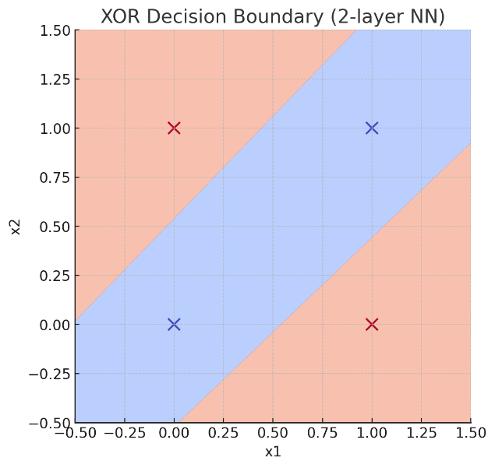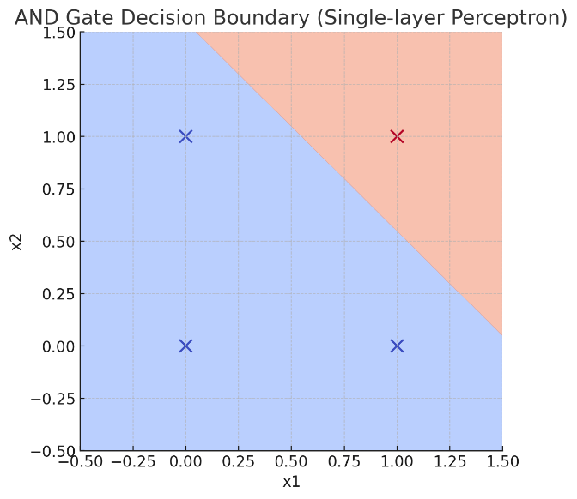**Part 2 Backpropagation**

**Simple multi-layer ANN and backpropagation**

**Training a ‘simple’ multilayer neural network to learn a simple task.**

On some occasions, the learning strategy is for you to have some experience in figuring out what is going on in the lab, and then I'll reinforce it with a detailed explanation in the following lecture. It's more effective this way to 'train' your brain to master the subject.

Actually, this is similar to many training methods used for artificial neuron networks. The networks are incrementally adjusted until they can 'learn' the subject or task.

Therefore, if you do not quite understand the whole details in the lab, it is still ok for now. What is important is you 'try' it repeatedly, and each time you gain a better understanding (i.e. ‘correct errors’). This will prepare your brain for the detailed discussion in the following lecture. (For those with a strong background, you can treat it as an exercise to refresh your memory.)

Note that training an ANN takes time; if you can't finish everything in the lab, you can carry on training and try in your own time or in the next lab.

**Backpropagation**

Consider the summary of the single-neuron training:

At the end of the lecture on Tuesday, I asked:

1. What does it mean ***‘training’*** an artificial neuron?
2. Why can your neuron be trained to make decisions based on one dataset, but can’t be train on a different dataset for a different task?
3. If we want our NPC to be intelligent enough to perform different tasks, which mean to posse some sort of ‘general intelligence’ or in other word your AI algorithm can be more ***generalised, what strategy should we take?***

**Answer:** Re-design our AI method/algorithms- single neuron does not sufficient to perform more difficult tasks, so we need more neuron to work together and more layers of neurons.

be

To solve the problem, we can propagate the error back to other neurons.

The error is propagated back ***through the relevant weights*** to the relevant neurons.

This is the most common type of neural networks where the data or signal flows forward and the error is propagated back to adjust the weights.

**Error (e) and error gradient (∇e or de/dw or δ)**

In this lab, Sigmoid function will be used as the activation function and 'error gradient ' will be used instead of 'error (difference between the current output and the correct output), see the figure below. Why? Please think about it, again to prepare you brain, before we discuss it in detail in the following lecture. We will explain what the derivative of an activation function is and explain why we decide at this point to use Sigmoid function not the Step function. We will also explain the learnable constant -bias and why bias is important. And how to learn bias.

**TASK**

Write Python code using Google Colab to implement the simple multilayer neural network above and the backpropagation training to make the network learn to handle a non-player character’s decision making process in your game - that is, whether the creature will attack of flee, depending on the creature’s power and enemy’s power.

You may notice that the number of inputs and outputs in this example are still the same as those in our single-neuron case. This is because it's easier to manage and study. If this works, then you can use the same method to more inputs, outputs and neurons.

(Note that for this type of decision, one neuron is not enough. If you wish, you could try it.)

|  |  |  |
| --- | --- | --- |
| INPUT | | OUTPUT |
| Creature’s power | Enemy’s power | Creature’s decision/action |
| Strong (1) | Strong (1) | Attack (0) |
| Weak (0) | Strong (1) | Flee (1) |
| Strong (1) | Weak (0) | Flee (1) |
| Weak (0) | Weak (0) | Attack (0) |

*- See an example pseudocode below; there are gaps you still need to fill. Then implement the code in Python using Google Colab.*

*- Pay attention to the epoch, sum error used to measure if the training converts to the correct weights and biases.*

*- Check your results against the table. Does the training work?*

**Example pseudocode for this training**

NB: This is an example of a very simple implementation. Once your code works, you can improve it to make it more effective and expandable to cope with more neurons, e.g. use functions and objects to represent each neuron, etc.

% AIGP Labs 5

Niteration = 1000000; % Number of iterations

%(by this number, you should have the result,

% otherwise, there may be something wrong in your code.

% Set initial weights and bias (normally, they are random numbers, but to

% make debugging easier, we begin with a fixed set of weights and biases

w(1,3) = 0.5; w(2,3) = 0.4;

w(1,4) = 0.9; w(2,4) = 1.0;

w(3,5) = -1.2; w(4,5) = 1.1;

Bias(3) = 0.8; Bias(4) = -0.1; Bias(5) = 0.3;

Alpha = 0.1; % Learning rate

%Prepare training data - inputs and correct outputs according to the

%decision table for the ANN to learn

x1(1) = 1; x2(1) = 1; Yd5(1) = 0; % Case 1

x1(2) = 0; x2(2) = 1; Yd5(2) = 1; % Case 2

x1(3) = 1; x2(3) = 0; Yd5(3) = 1; % Case 3

x1(4) = 0; x2(4) = 0; Yd5(4) = 0; % Case 4

p = 1; % iteration number

while p <= Niteration

EpocSumError = 0; % Initiate the termination condition value

% Begining of an Epoch

for i = 1:4 % Case number

p % print iteration number

%%%%%%%%%%%%%%%%%%%%%%%%%%%%%%%%%%%%%%%%%%%%%%%%%%%%%%%%%%%%%%%%%%%

% FEED FORWARD

% Calculate output for neuron 3

z(3) = x1(i)*w(1,3)+x2(i)*w(2,3)+Bias(3);

% Activation Function - Sigmoid function ()

% Note: exp(1) = e^1 = 2.7183 (Euler’s number)  
 % (see the labsheet and lecture notes last week)

y(3) = …..[You need to find out here how to calculate output y(3) of neuron 3]

% Calculate output for neuron 4

z(4) = x1(i)*w(1,4)+x2(i)*w(2,4)+Bias(4);

% Activation Function - Sigmoid function

y(4) = …..[You need to find out here how to calculate output y(4) of neuron 3]

% Calculate output for neuron 5

z(5) = y(3)*w(3,5)+y(4)*w(4,5)+Bias(5);

% Activation Function - Sigmoid function

y(5) = …..[You need to find out here how to calculate output y(5) of neuron 3]

%%%%%%%%%%%%%%%%%%%%%%%%%%%%%%%%%%%%%%%%%%%%%%%%%%%%%%%%%%%%%%%%%%%

% BACK PROPAGATION

% Back propagate the error and use the learning rule to update the

% weights

% Starting from neuron 5

%........................................................

% COST FUNCTION

% Calculate the cost (error) at the output of the network to propage back

% through the network

% Note that this one is the simplest cost (error) function (see the

% lecture notes). It is used to update the weights in the case,

% then use the new weights for the next case in the Epoch.

% Later, you could try other cost function such as Quadratic cost

% (see the lecture notes), but be aware, for Quadratic cost, you

% first calculate the cost (error) from all cases in the Epoch, then use

% that cost to propagate back and update the weights.

e(5) = Yd5(i) - y(5);

%..................................................................

Delta(5) = y(5)*(1-y(5))*e(5);

Wcurrent(3,5) = w(3,5); % save the current value before updating it

Wcurrent(4,5) = w(4,5); % save the current value before updating it

w(3,5) = w(3,5) + Alpha*y(3)*Delta(5);

w(4,5) = w(4,5) + Alpha*y(4)*Delta(5);

Bias(5) = Bias(5) + Alpha*(1)*Delta(5);

% Neuron 3

Delta(3) = y(3)*(1-y(3))*Delta(5)*Wcurrent(3,5);

w(1,3) = w(1,3) + Alpha*x1(i)*Delta(3);

w(2,3) = w(2,3) + Alpha*x2(i)*Delta(3);

Bias(3) = Bias(3) + Alpha*(1)*Delta(3);

% Neuron 4

Delta(4) = y(4)*(1-y(4))*Delta(5)*Wcurrent(4,5);

w(1,4) = w(1,4) + Alpha*x1(i)*Delta(4);

w(2,4) = w(2,4) + Alpha*x2(i)*Delta(4);

Bias(4) = Bias(4) + Alpha*(1)*Delta(4);

%%%%%%%%%%%%%%%%%%%%%%%%%%%%%%%%%%%%%%%%%%%%%%%%%%%%%%%%%%%%%%%%%%%

% Check the error for the whole epoch (all cases) to see if the set

% of the weights and biases produce correct outputs for all cases

% (Epoch).

% Note that if you use Quadratic cost, then you can use the

% Quadratic cost value as the condition, don't need to calculate

% this part

% Accumulating the sum of 'squared' errors in the Epoch

% Recalculate the error at the end e(5) after updating all the

% weights and biases

% [Check what the code below means, why?]

tX(3) = x1(i)*w(1,3)+x2(i)*w(2,3)+Bias(3);

ty(3) = 1/( 1 + (exp(1))^(-(tX(3))));

tX(4) = x1(i)*w(1,4)+x2(i)*w(2,4)+Bias(4);

ty(4) = 1/( 1 + (exp(1))^(-(tX(4))));

tX(5) = ty(3)*w(3,5)+ty(4)*w(4,5)+Bias(5);

ty(5) = 1/( 1 + (exp(1))^(-(tX(5))));

te(5) = Yd5(i) - ty(5);

% Squared error

EpocSumError = EpocSumError + (te(5))^2; %[What is EpocSumError? What does it do?]

p = p+1;

end % for i = 1:4

% The training process is repeated until the sum of squared error in

% The Epoch is acceptable, i.e. less than, for example, 0.001. We have to do this because you won’t get the exact zero error

*** Put termination condition here ****

EpocSumError

if EpocSumError < 0.001 % Example

break

end

end % while p <= Niteration

***When programming, it is a good practice to check carefully. For each step, check the results against the equations to ensure that the code is correct before running the whole thing for many iterations. This is a good way to practice implementing and debugging your code.***

For example, in the first iteration, the values of the variables should be as follows. If your code produces results far from the values below, then you need to check for bugs:  
  
First iteration p = 1  
y(3) = 0.8455  
y(4) = 0.8581  
y(5) = 0.5571  
e(5) = -0.5571  
Delta(5) = -0.1375  
w(3,5) = -1.2116  
w(4,5) = 1.0882  
Bias(5) = 0.2863  
Delta(3) = 0.0215  
w(1,3) = 0.5022  
w(2,3) = 0.4022  
Bias(3) = 0.8022  
Delta(4) = -0.0184  
w(1,4) = 0.8982  
w(2,4) = 0.9982  
Bias(4) = -0.1018  
te(5) = -0.5483  
EpocSumError = 0.3007

**SOLUTIONS**

The final weights and biases should be (approximately):

w(1,3) = 4.5742  
w(1,4) = 6.6165  
w(2,3) = 4.5669  
w(2,4) = 6.5849  
w(3,5) = -10.5474  
w(4,5) = 9.7713

Bias(3) = -7.0188; Bias(4) = -2.9530; Bias(5) = -4.5013

Note that, from a multi-layer ANN, you won’t get the clear, exact values for the desired outputs and exact zero errors. For example:

**END**